**Bank Management Database Manual**

**a. Description of Business Scenario:**

The Bank Management System is designed to facilitate efficient management of banking operations. It caters to the needs of customers, employees, and administrators by providing a seamless platform for account management, transactions, loan processing, credit card management, and employee management. The system aims to streamline banking processes, enhance customer experience, and ensure regulatory compliance.

**b. List of Business Entities (Tables):**

1. **Account Table**: Stores information about bank accounts, including account type, account number, open date, close date, customer ID, status, balance, currency, and last transaction date.
2. **Customer Table**: Contains details of bank customers, such as customer ID, customer type, first name, last name, address, phone number, email, and date of birth.
3. **Branch Table**: Manages information related to bank branches, including branch ID, branch name, location, and manager ID.
4. **Employee Table**: Stores data about bank employees, including employee ID, first name, last name, role, salary, and branch ID.
5. **Loan Table**: Handles details of loans provided by the bank, including loan ID, customer ID, loan type ID, amount, interest rate, term, start date, end date, status, and branch ID.
6. **Loan Type Table**: Stores different types of loans offered by the bank, including loan type ID, loan type, and description.
7. **Credit Card Table**: Contains information about credit cards issued by the bank, including credit card ID, expiry date, card limit, customer ID, and account number.
8. **Loan Payments Table**: Manages payments made towards loans, including payment number, payment date, payment amount, and loan ID.
9. **Transaction Table**: Handles details of transactions conducted by customers, including transaction ID, account number, transaction type, amount, transaction date, description, transaction time, and transaction branch ID.
10. **Transaction Type Table**: Stores different types of transactions, including transaction type ID, transaction type, description, and limit.
11. **Account Type Table**: Contains different types of bank accounts offered by the bank, including account type and account type description.
12. **Customer Type Table**: Stores different types of bank customers, including customer type and customer type description.

This manual provides an overview of the Bank Management System and its key business entities, which collectively contribute to the efficient management of banking operations.

**c. ERD Snapshot:**

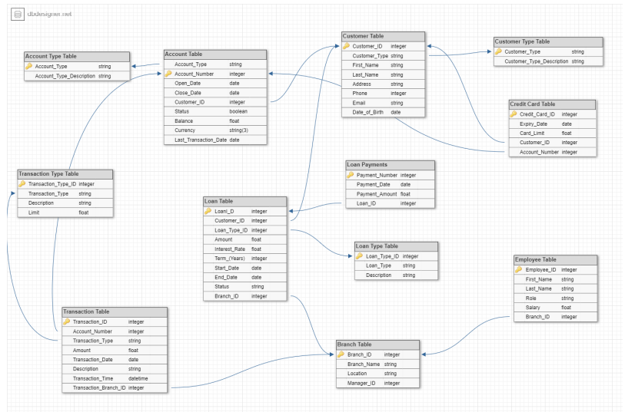

**d. Steps needed to replicate the database. (Chosen RDBMS, DDL script, steps to populate the dummy data, etc.**

The SQL DDL Script is provided, and the data set is also given in the form of excel sheets. We used MySQL as RDBMS. You can run the DDL script and insert/upload the data provided in excel sheet. There is only a single excel file there which contains 12 tabs each for table. There are 12 tables in total.

**There is no python script to generate sample data. We used Chat-GPT to generate the sample data.**